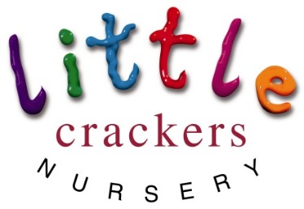
Weekly News

21st May 2018
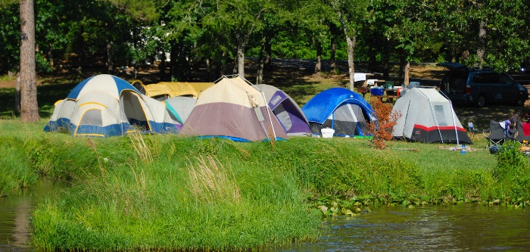

Dates for your diary…  Sports Day  Thursday 14th June 2018  9.30-10.30 am  Graduation Day (for the pre-school)  Wednesday 4th July 2018 2-3pm  (2 tickets per child)  Term Time children finish  Friday 6th July  48 Weeks children finish  Friday 10th August  Nursery Bits and Bobs…  Please send in named sun-cream.  Our policy is to add extra sun-cream if necessary during the day, but we do request that you put sun-cream on your child before you drop them off. | https://www.nhs.uk/live-well/healthy-body/sunscreen-and-sun-safety/  Children and sun protection  Take extra care to protect babies and children. Their skin is much more sensitive than adult skin, and damage caused by repeated exposure to sunlight could lead to skin cancer developing in later life.  Children aged under six months should be kept out of direct strong sunlight.  From March to October in the UK, children should:  - cover up with suitable clothing  - spend time in the shade – particularly from 11am to 3pm  - wear at least SPF15 sunscreen  Apply sunscreen to areas not protected by clothing, such as the face, ears, feet, and backs of hands.  Get more sun safety advice for children.

What do you get if you cross an elephant with a fish?
+ = | Swimming trunks!!! | 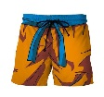

Little Crackers Nursery · Crackley Hall · St Joseph’s Park · Kenilworth · CV8 2FT
Telephone: 01926 514444 · Fax: 01926 514455 · e-mail: littlecrackers@crackleyhall.co.uk
www.crackleyhall.co.uk

Registered Charity Number 1087124 Company limited by guarantee Number 4177718

You can email Mrs Bird clarebird@crackleyhall.co.uk
or ring the nursery direct 01926 514456

